**Level 1: File Handling Definitions**

Use the following resources to answer the questions about file handling in Python.

· <https://www.pythonforbeginners.com/files/reading-and-writing-files-in-python>

· <https://www.pythonforbeginners.com/cheatsheet/python-file-handling>

1. Explain the function of each of the following file handling commands

a. The open() function

The open function opens the file with the name and the mode it will be opened in.

b. The read() method

The read function is used to read the file that you have opened using the open function.

c. The readline() method

The readline function is used to read one specific line from the content, instead of reading everything.

d. The write() method

The write file is used to add more lines of text to the current file.

e. The close() method

This finishes up the file, and closing it so that nothing can be changed after you’ve made the file close.

2. Research and explain the “Mode” used to open files in a Python program.

a. ‘r’ mode

R mode is used to read the file

b. ‘w’ mode

W mode is used to write to a file

c. ‘a’ mode

A mode is used to append a file

d. ‘r+’ mode

This mode is used to read and write to a file

e. Explain when and where the mode is used in a Python program

These modes are used in the arguments of the parameters that you place after opening the file.

3. Provide example code which opens a text file for reading and prints the contents of the file to the console display.

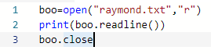

a. Explain what each line of the program does.

The first line opens the file with the “r” mode. The second line reads and prints the line in the file. The third line closes the file so that no more changes can occur.

4. Provide example code which opens a text file for writing and writes some data to the file.

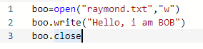

a. Explain what each line of the program does.

The first line opens the file in “w” mode. The second line writes the line “Hello, i am BOB” to the file. The third line closes the file so no more changes can occur.

5. Research and explain the difference between a “File Name” (type Python string) and

a File Object (type Python object).

A Filename will call the file, and is a name for the file, whereas the File Object is a return once you’ve called the Filename which then gets used with the mode that you’ve assigned to the File Object.

**Level 2: Reading & Writing Files**

1. Add a text file to your project as follows:

· Click on “Add File” icon in the files pane/window.

· Type “myfile.txt” and return.

· “myfile.txt” is now open in the editor pane/window.

· Type some text into “myfile.txt”

· Make sure to add several lines of text. A sample file contents could look like:

*Hello kind student\n*

*This is a message from your computer\n*

*I hope you are having fun learning to program\n*

*Remember to ask Mr. Nestor questions when you don’t understand.*

2. Write a program that opens “myfile.txt” for reading and prints the contents to the file to the console display.

a. The program should also print out the number of lines in the file

b. Provide a listing of your program below

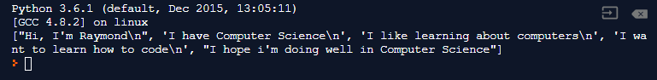

3. Write a program that opens “myfile.txt” for appending new contents to the file.

a. You can “hard code” some commands to write new text to the file

b. Make sure to use the close() method when your are finished.

(What happens if you don’t?)

Then the next action that you assign will make changes to the file selected beforehand. When you close the file, nothing else can be changed to it.

c. How can you tell that your program worked? (That the contents changed?)

Yes the contents have changed, and there are no error messages present.

d. Provide a listing of your program below

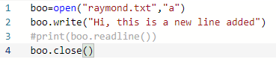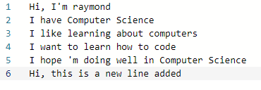

4. Write a program that opens “myfile.txt” for writing new contents to the file.

a. You can “hard code” some commands to write new text to the file

b. Explain the difference between appending and writing to a file.

When you append to a file, you add new information onto the old information and what’s already there. When you write to a file, it replaces all of the old information with the new information that you want to write to the file.

c. Provide a listing of your program below

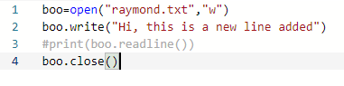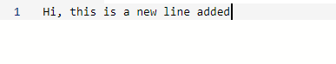

**Level 3: Folders & Binary Files**

1. Add a folder called “resources” to your project as follows:

· Click on “Add Folder” icon in the files pane/window.

· Type “resources” and return.

2. Drag and drop your “myfile.txt” file into the “resources” folder.

3. Run you program from Level 2 to see what happens.

a. Why does it give an error?

For me, for both appending and writing, python does not give an error and simply creates a new text file outside of the resources folder that I have created.

b. How can you modify the file name string used by the open() function so that it also includes the “resources” folder?

You can modify it by putting a slash in front of the file name, and add the name of the folder. So in my case, I would add “resources/” before “raymond.txt”.

c. Fix the open() function so that the program runs correctly and provide your program listing below.

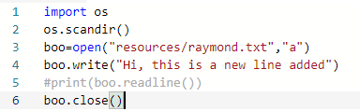

4. Research and explain the “Binary Mode” used to open files in a Python program.

a. What is the ‘rb’ mode and how is it different from the ‘r’ mode

Rb mode opens the file in binary mode, and opens it for reading in binary mode, instead of reading the file in regular reading mode.

b. What is the ‘wb’ mode and how is it different from the ‘w’ mode

Wb mode opens the file in binary mode, to be used to write in binary mode instead of writing in regular mode.

5. Add the “Penguin.bmp” binary image file to your repl project as follows:

a. Download the “Penguin.bmp” file from the GitHub repository to your desktop

b. Drag and drop the “Penguin.bmp” from your desktop to the “resources” folder in your repl project

c. Click on the “Penguin.bmp” to make sure everything is ok.

6. Modify your Level 2 program to open the “Penguin.bmp” and print its contents to the screen.

a. Provide a listing of your modified code below

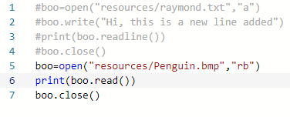

b. Explain what you see as output compared to the penguin image itself

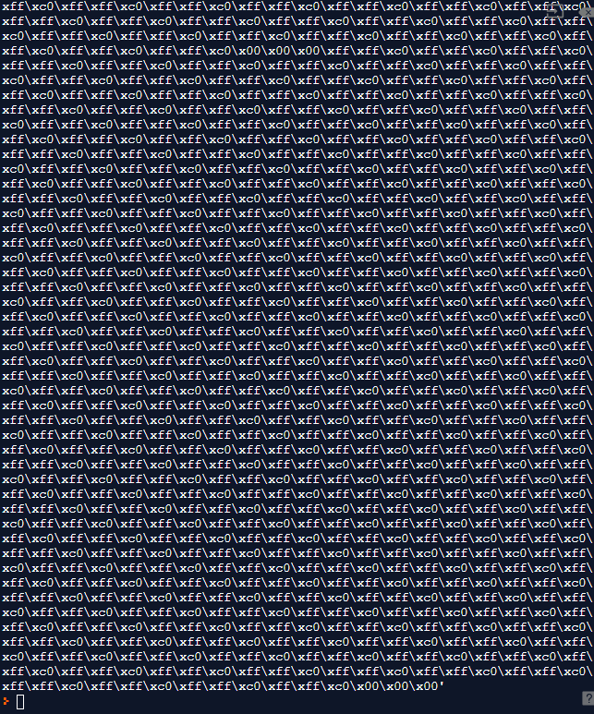

You see each individual pixel mapped out with the colour, and it is in binary mode, so you do not see andy colour or the picture itself, only the coding behind the scenes.